6.25: a) Combining Equations (6.5) and (6.6) and solving for 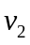 algebraically,

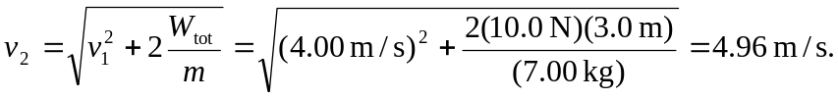

Keeping extra figures in the intermediate calculations, the acceleration is From Eq. (2.13), with appropriate change in notation,
giving the same result.

